**Project Report**

**Đoàn Trọng Thái – HE153736 ( SE1603)**

1. Introduce case of study:

- In today's covid-19 situation, we should, as much as possible, avoid crowds and limit from outdoor spaces. However, consumer demand is still increasing day by day. Since we cannot get out of online shopping, e-commerce is the solution to this need. So I created an online shopping site based on the knowledge I got from PRJ301 at school. Here is my summary of my project.

II. Database design:

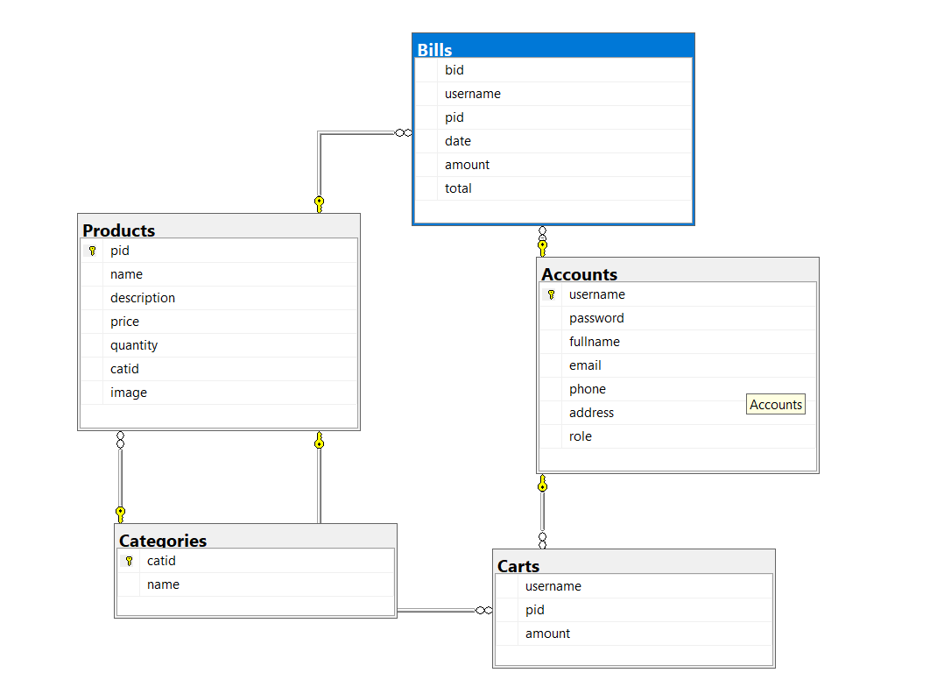

III. System design:

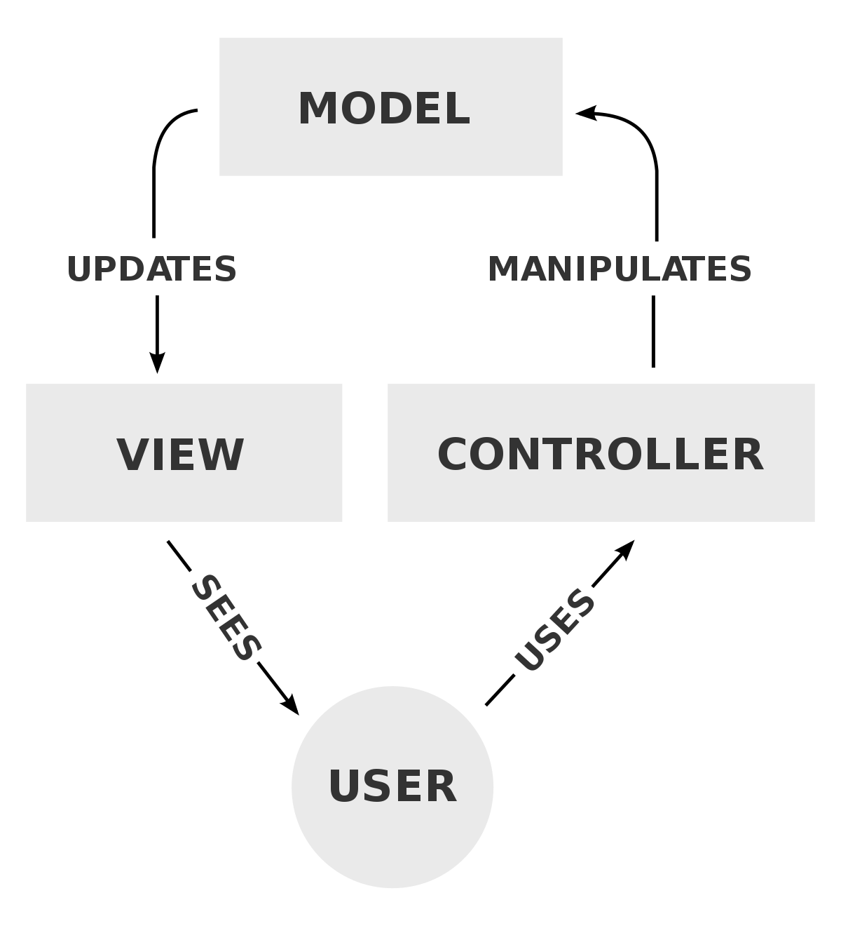- This project is designed using knowledge about JSP- Java Servlet and based on software design pattern MVC - stands for Model – Controller – View, commonly used for developing user interfaces that divide the related program logic into three interconnected elements. This is done to separate internal representations of information from the ways information is presented to and accepted from the user.

1. Model: All data-related logic that the user interacts with is represented by the Model component. In my project we have model like:

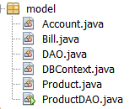

This might be the data that is being transferred from database or between the View and Controller components, or any other data that is linked to business logic.

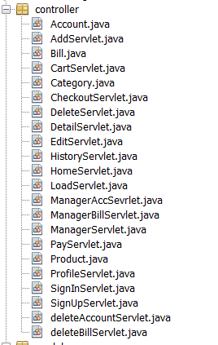2. Controller:

Controllers act as an interface between Model and View components to process all the business logic, incoming requests and directional url, manipulate data using the Model component and interact with the Views to render the final output.

3. View:

View is that what the users, customers can see. It will be directional by controller after get request from users. In this project, I used JSP ( include HTML5, CSS and JavaScript) to build.

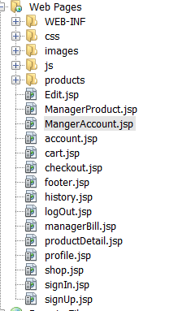

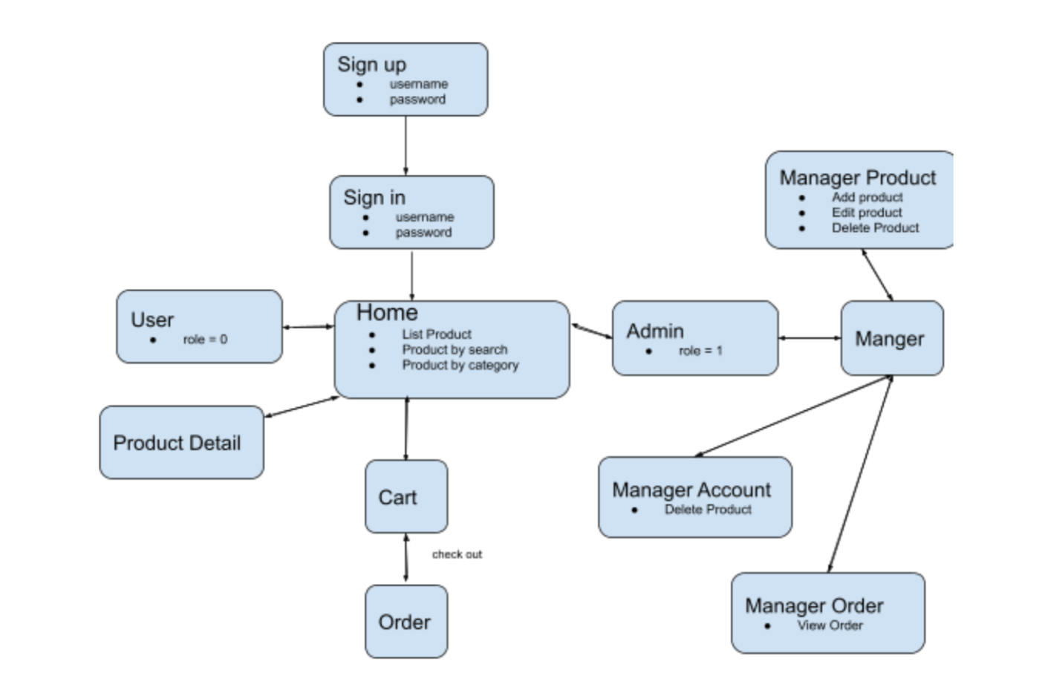

Overview

**IV. Screenshot:**

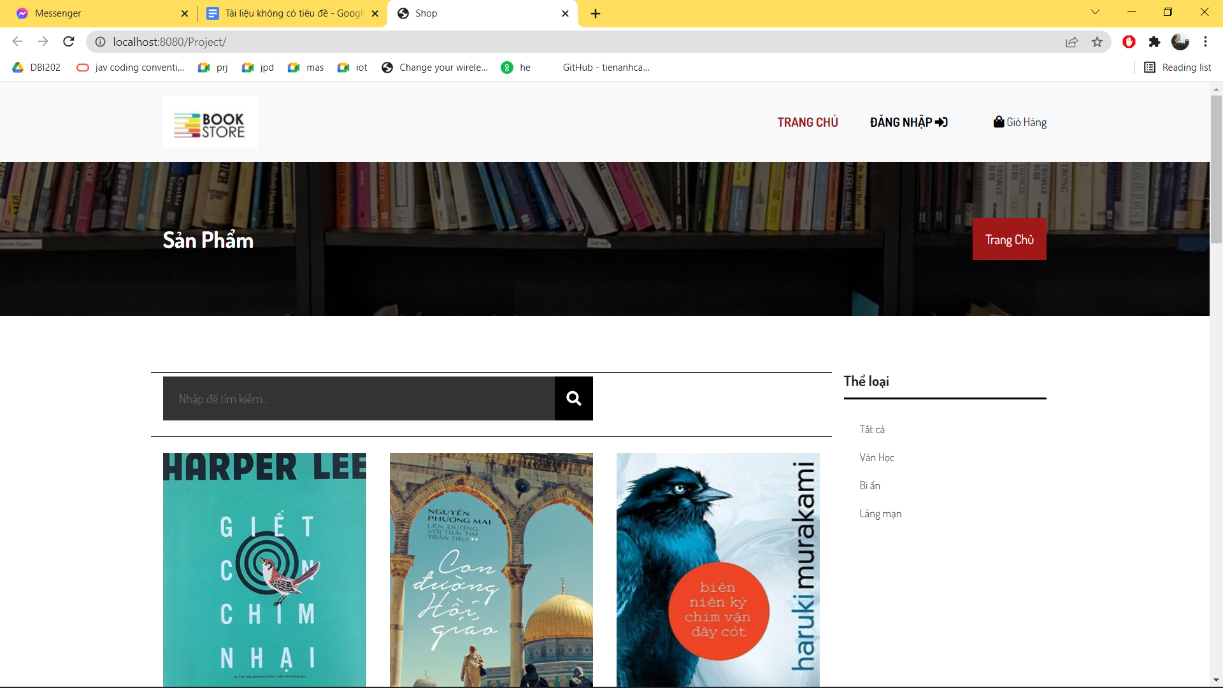

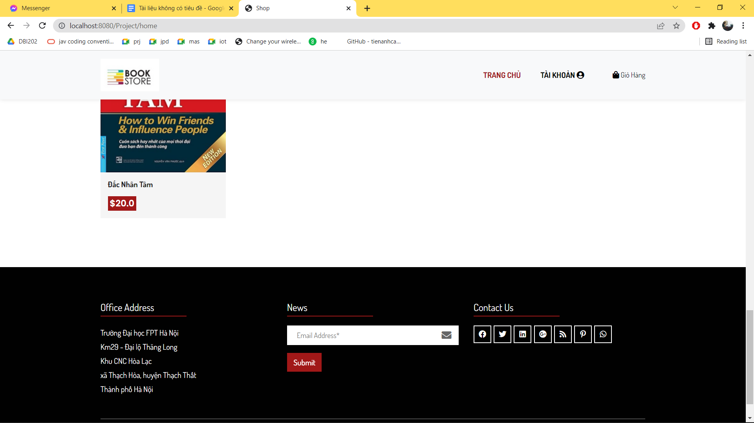

HomePage(user and guest)

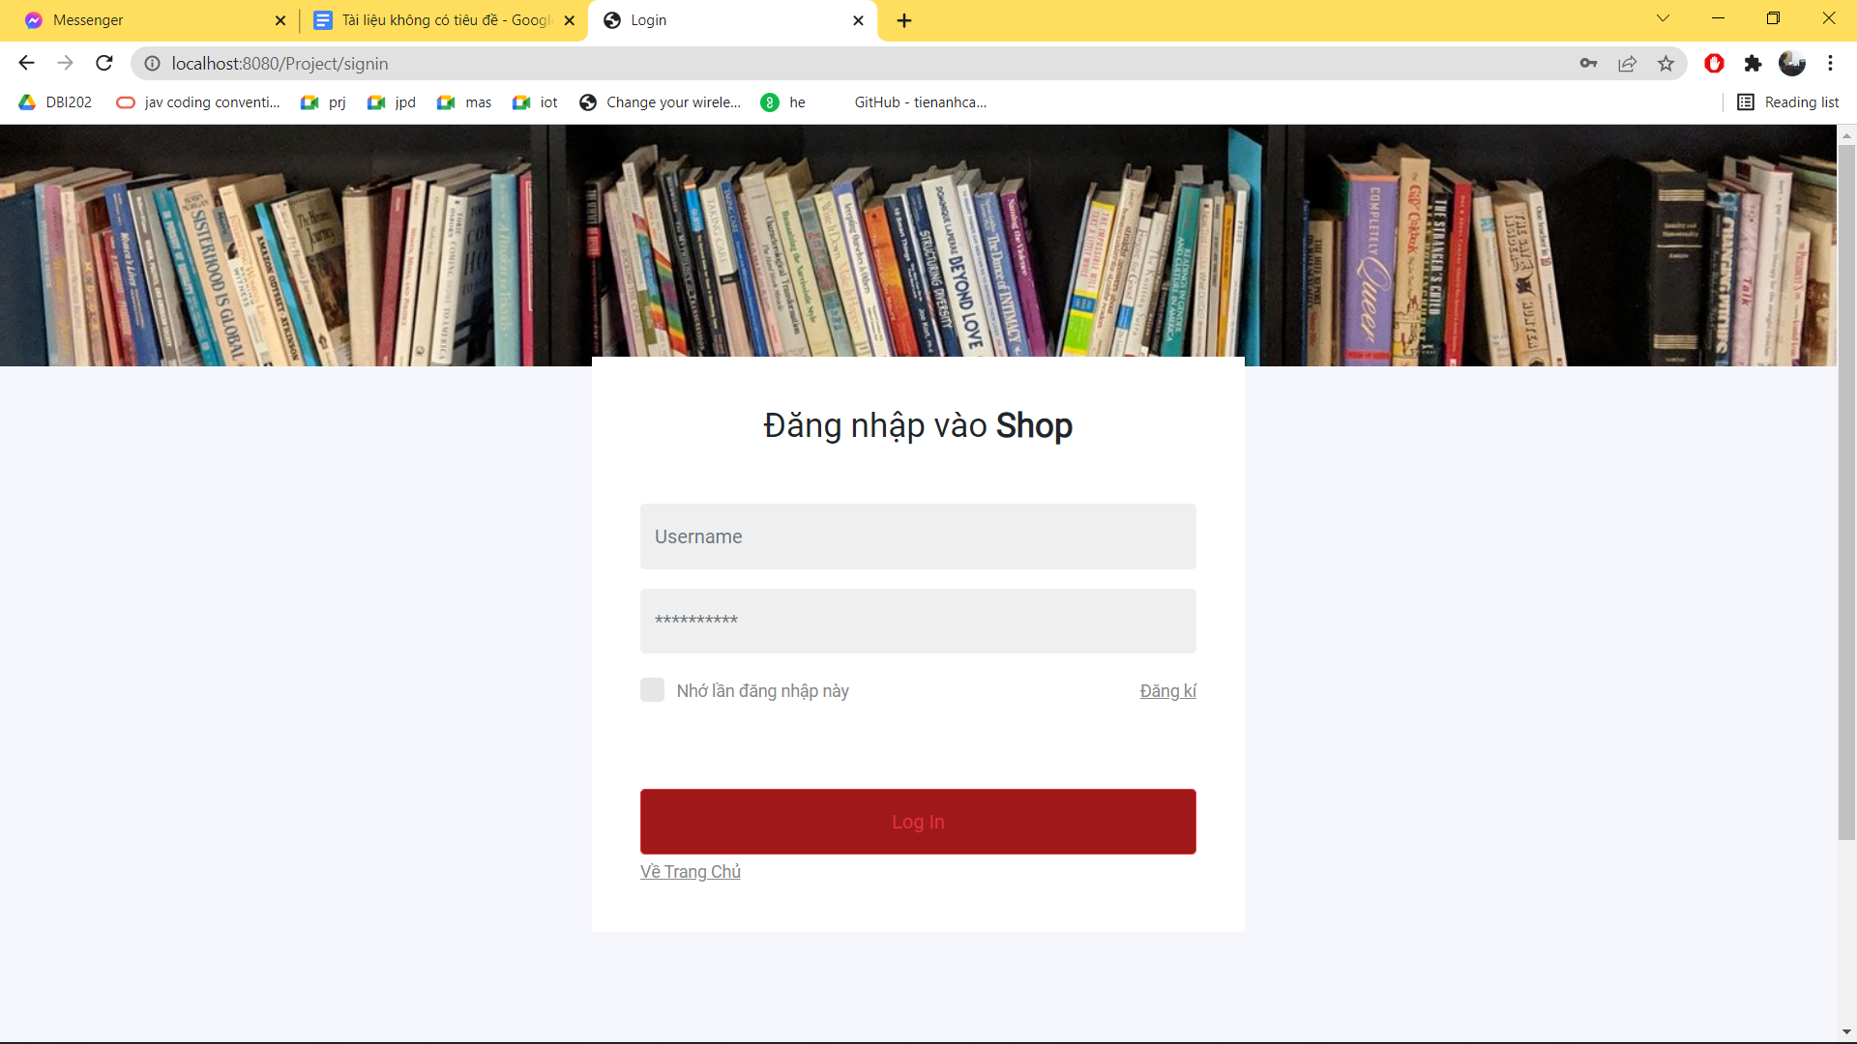

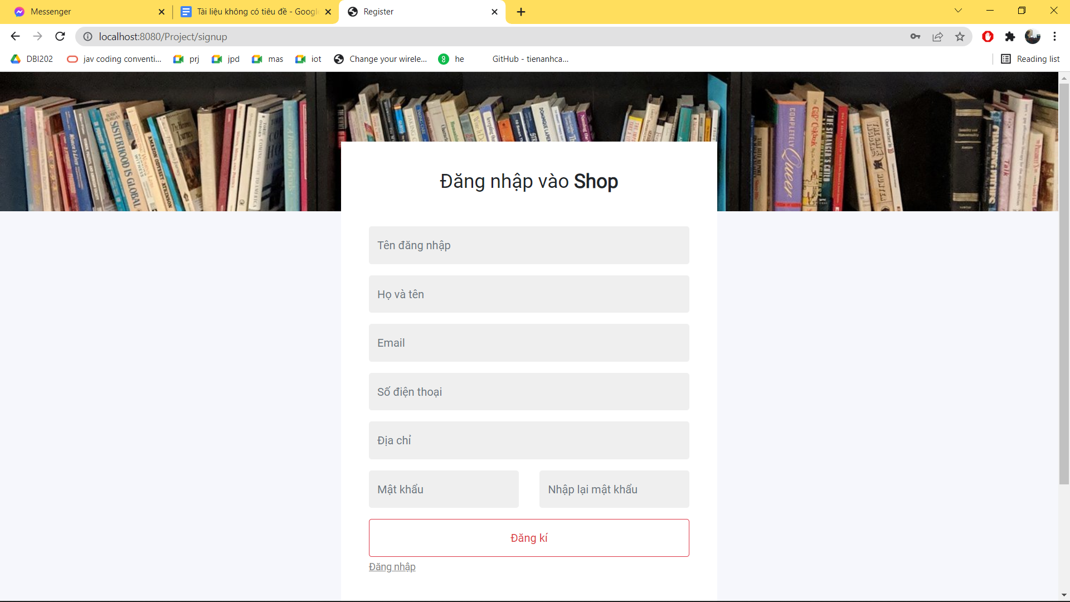

Sign in – Sign up

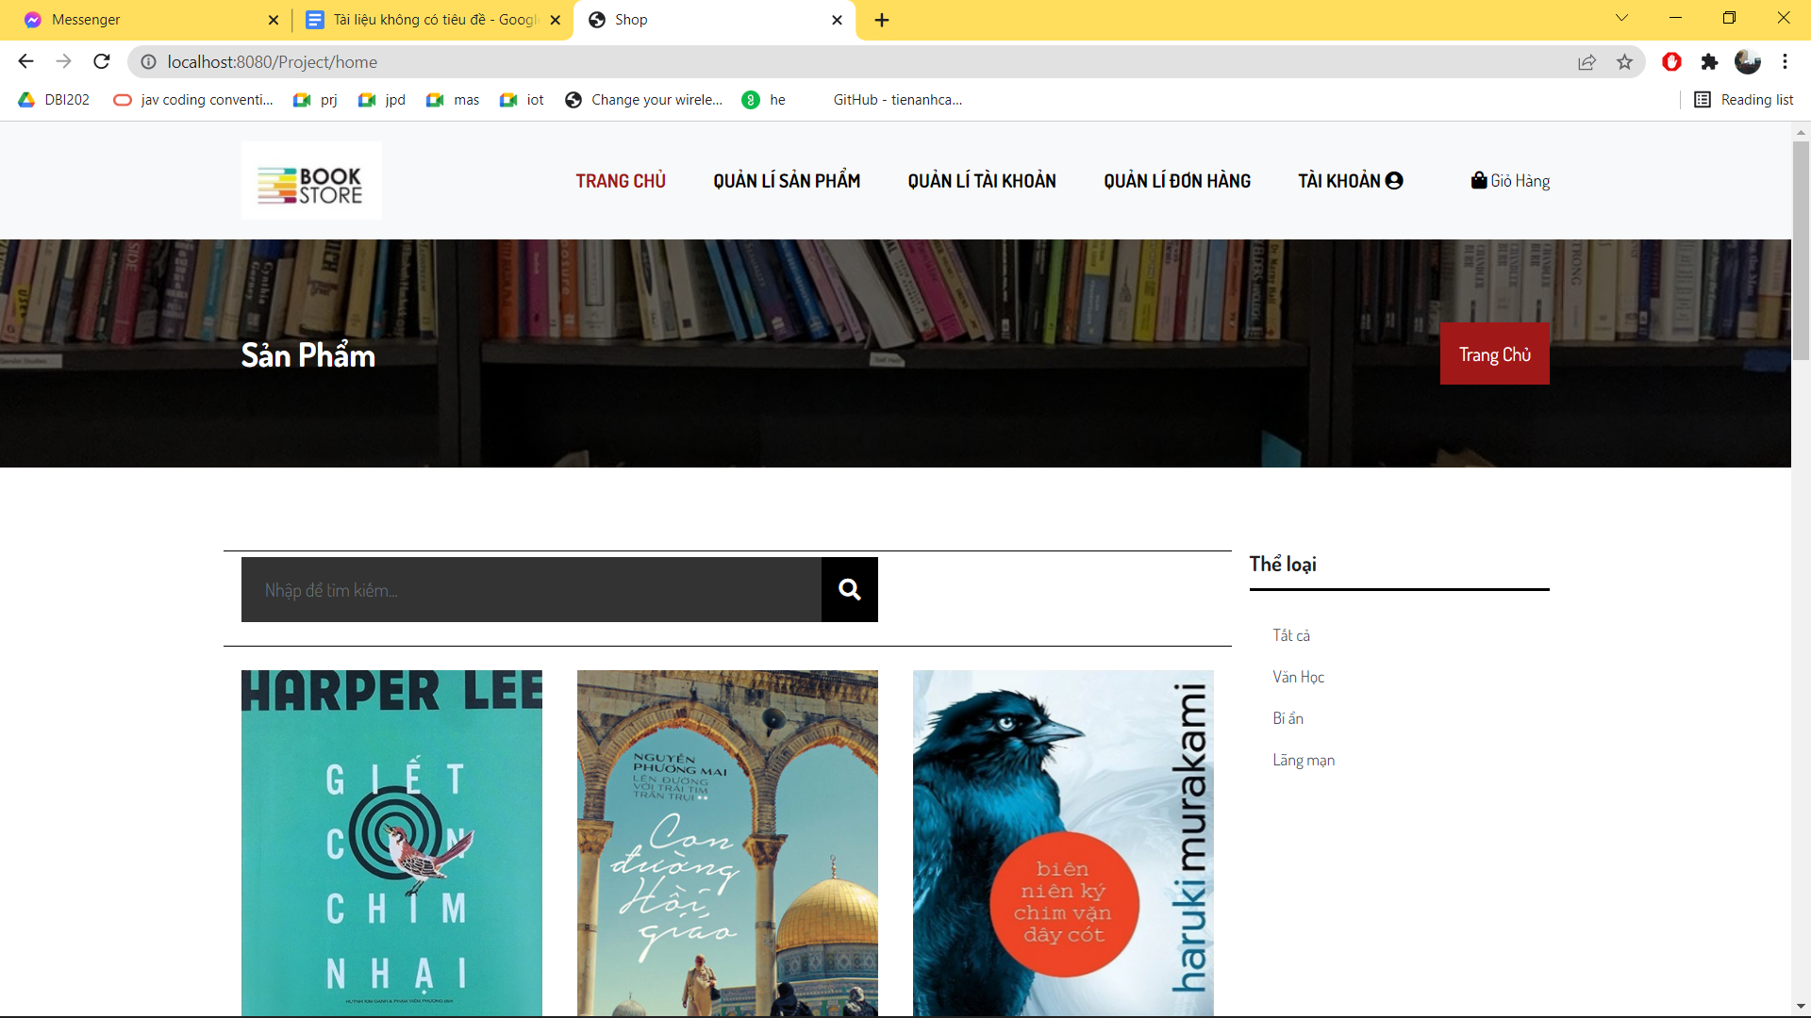

Home ( admin )

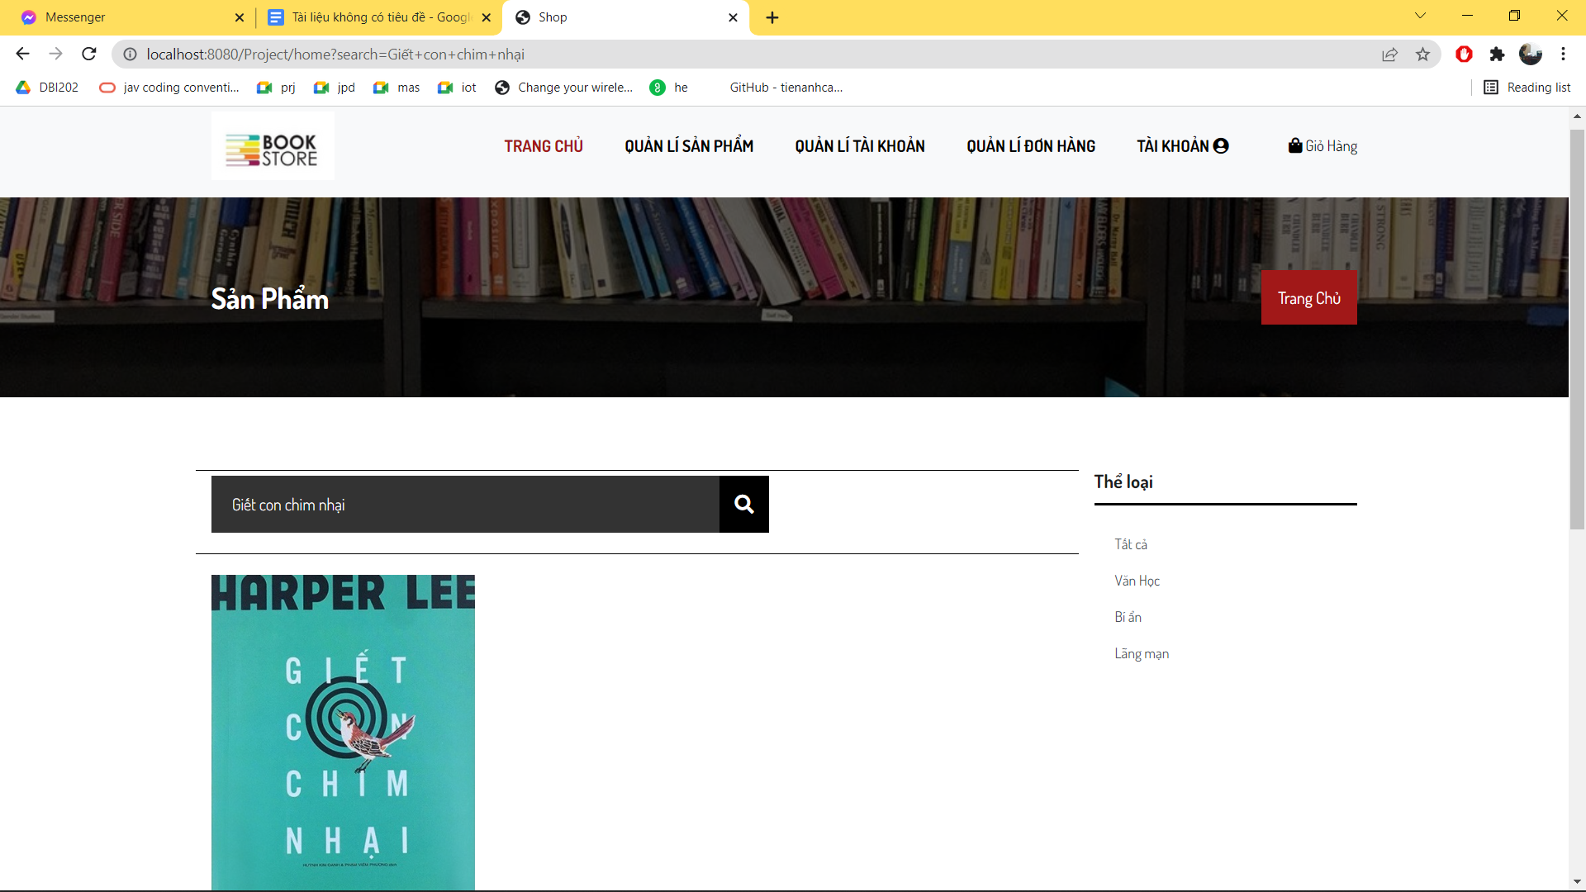

Product by search

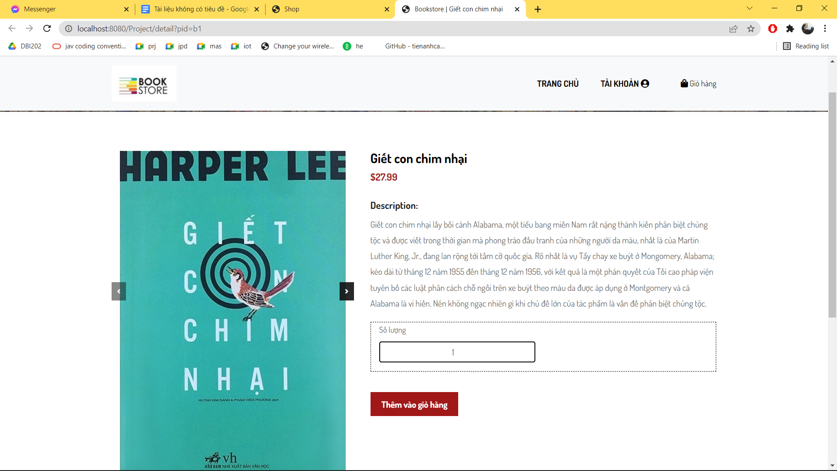

Detail Product

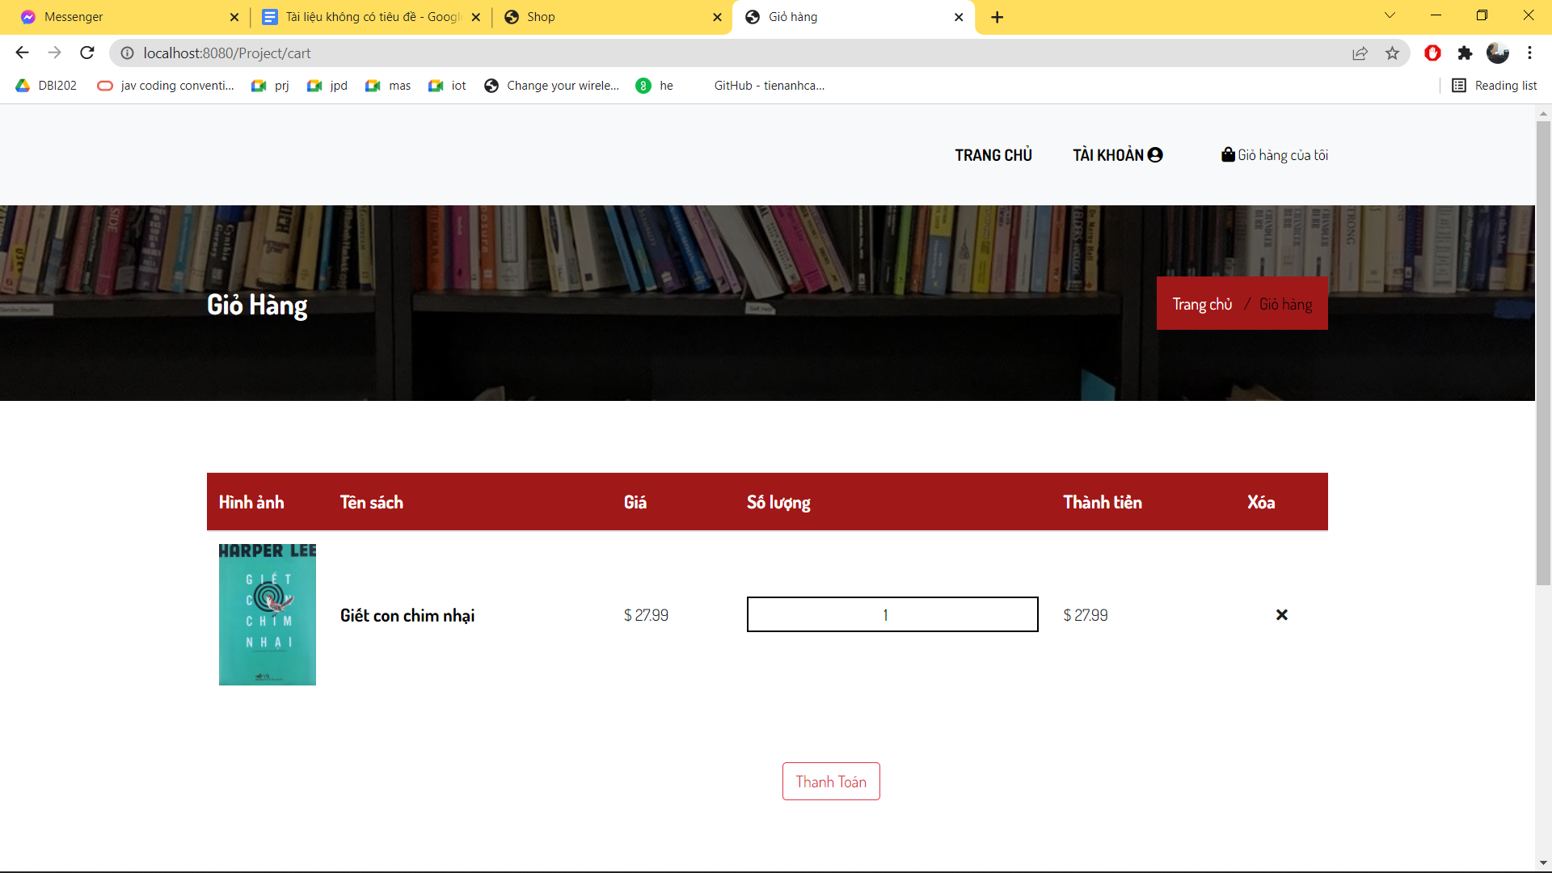

Cart ( 1 product )

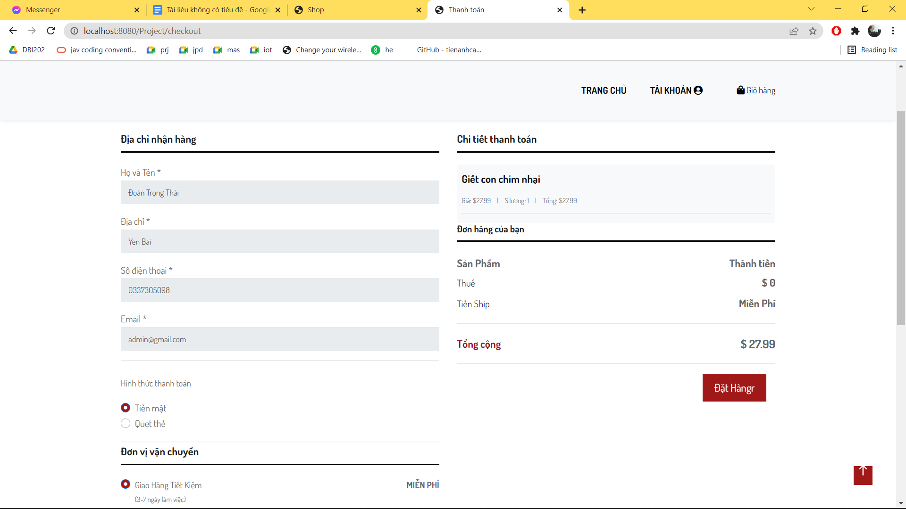

Check out

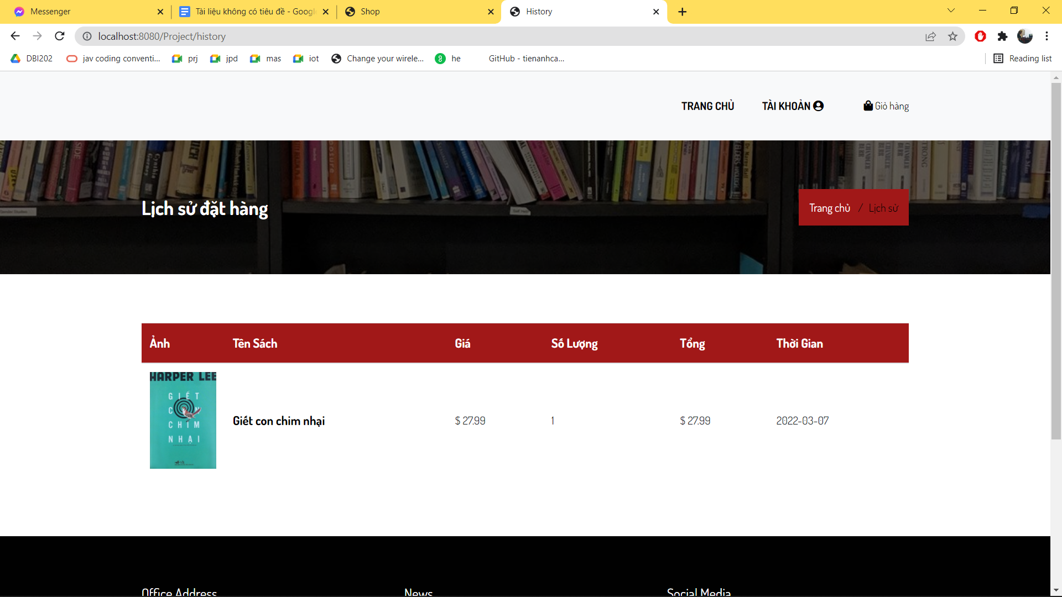

History Order

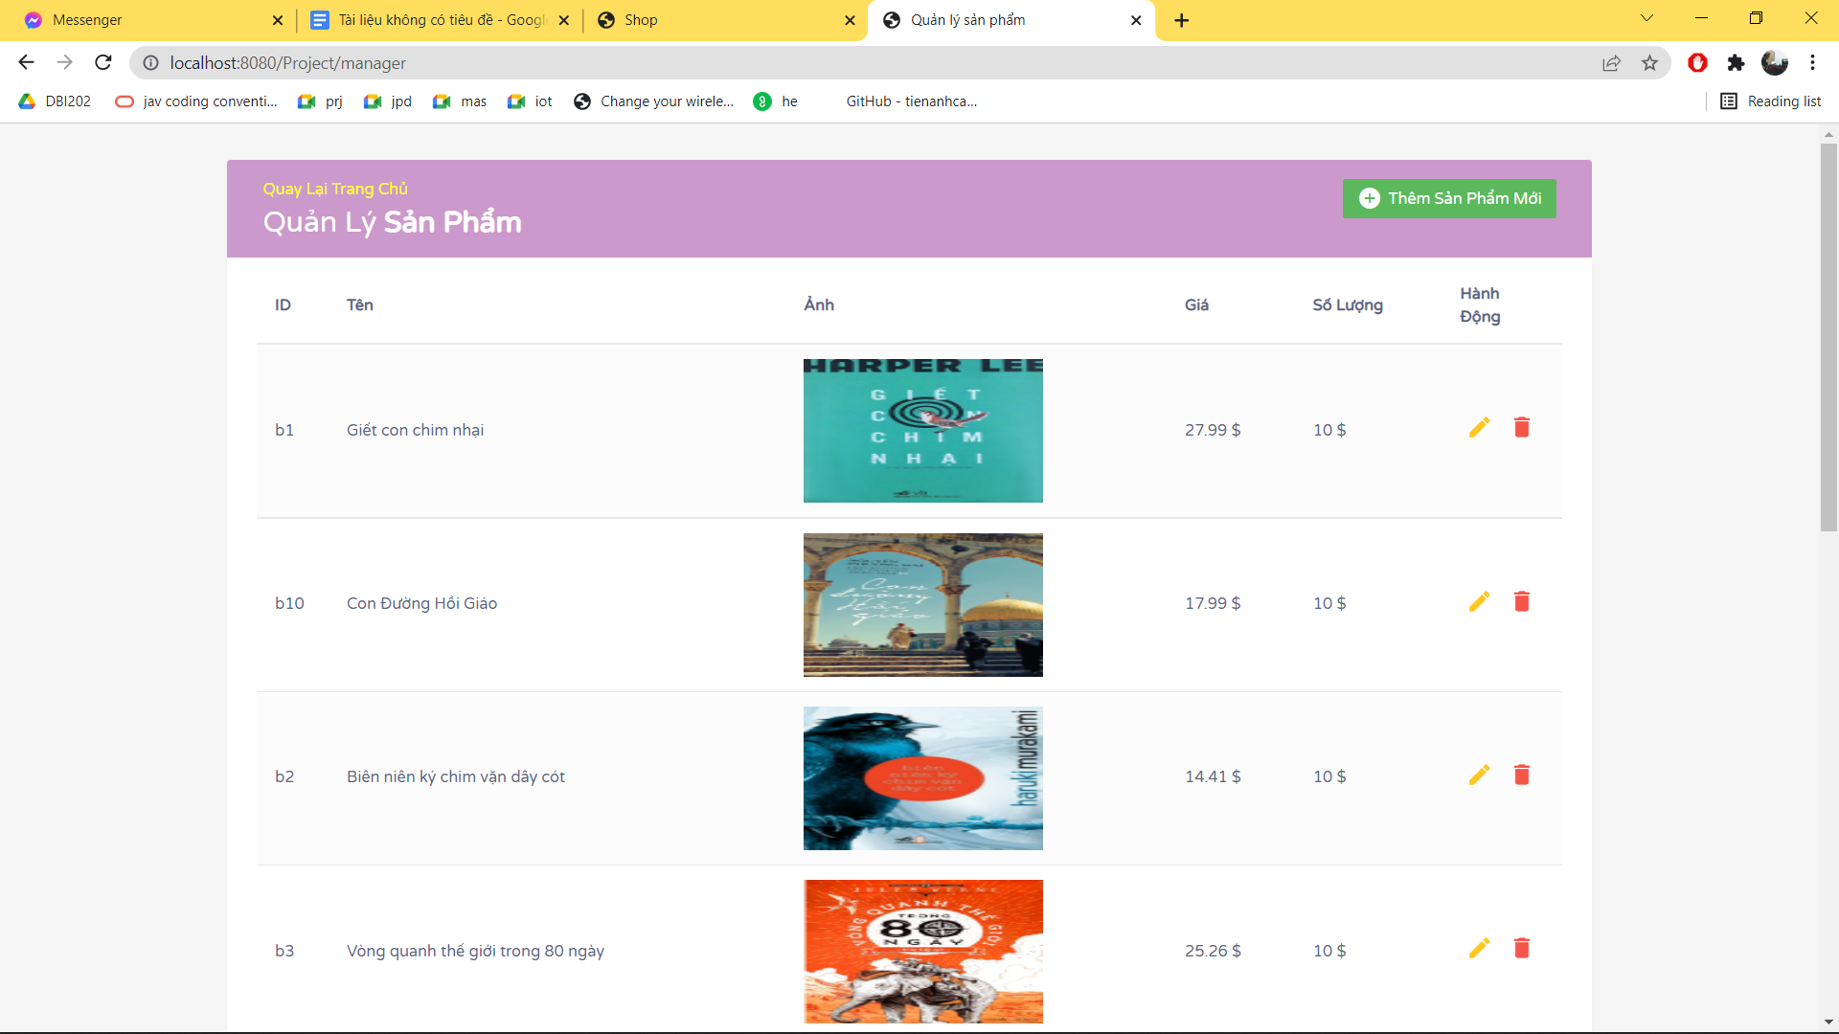

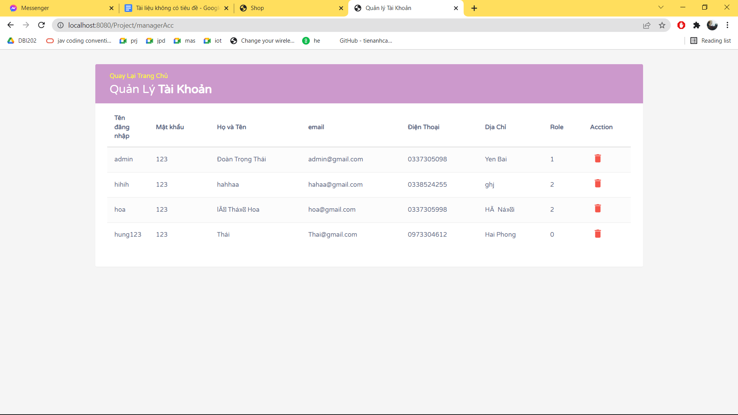

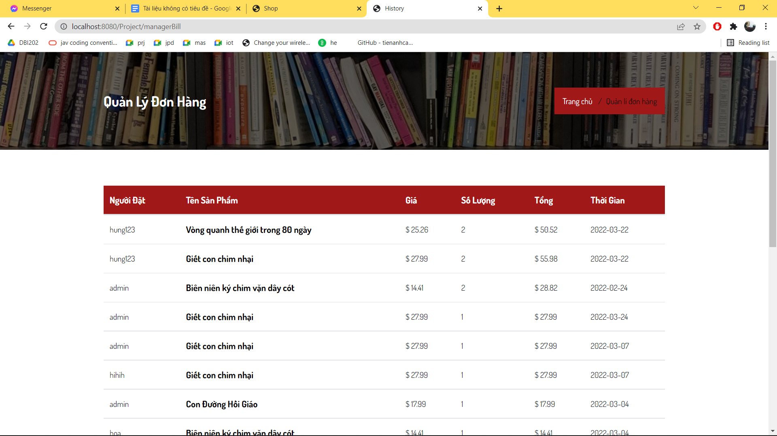

Manage Products, Accounts, Orders ( Admin only )

**V. Conclusion and Discussion:**

**A. Conclusion:**

1. Friendly interface, easy to use

2. Fully features, utilities

3.Admin management system ( product, account, order)

**B. Discussion:**

-This assignment is necessary because after finish this project, we can make your own website using your knowledge gain from study. Beside, we can find other mistakes that we only can discover if we make the project on your own: bugs, how to debug, find solutions. We can feel the proud of myself after finish something quite big (at the moment).

-Some reference sources used in project: stackoveflow, template front-end